You will be introducing to a new function – “if” statements! They are very similar to “while” loops, look:

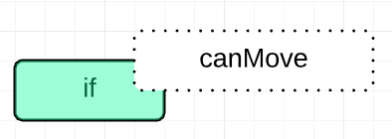

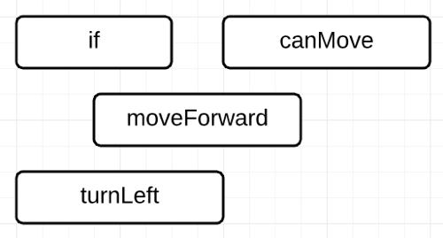

They act differently, however, because it’s not a loop and it doesn’t repeat (just once if condition is satisfied).